|  |  |  |
| --- | --- | --- |
| VILNIAUS KOLEGIJA  UNIVERSITY OF APPLIED SCIENCES  FACULTY OF ELECTRONICS AND INFORMATICS  https://screenshotscdn.firefoxusercontent.com/images/eaf3f7f3-2952-4801-af5c-4f20e8ae8b88.png | | |
|  | | |
| **INVESTIGATION OF USB INTERFACE** | | |
|  | | |
|  | | |
| LABORATORY WORK  6531BX028 PI18E | | |
| STUDENTS | (SIGNATURE) | U**Ğ**UR FIRAT  DŽIUGAS PEČIULEVIČIUS |
| 2020-03 |
| (SIGNATURE) |
| 2020-03 |
| (SIGNATURE) |
| LECTURER | 2020-03 | MARTYNAS ŠAPUROV | |

# OBJECTIVE

Understand the basic operation principles of Universal Serial Bus (USB). Collect the detailed information about various USB devices connected to the computer. Analyze the data flow types used by these USB devices and measure data transfer rates. Analyze the enumeration process, USB packet fields, packet types and NRZI data encoding.

# TEST RESULTS OF USB MICE (TASKS 2-4)

……………....

# RESULTS OF USB FLASH DRIVE SPEED TEST (TASK 5)

…………

# ANALYSIS RESULTS OF THE ENUMERATION PROCESS OF USB DEVICE (TASK 6)

...................

# EXAMPLES OF NRZI ENCODED DATA STREAM (TASK 7)

...................

# ANALYSIS RESULTS OF USB SIGNAL WAVEFORMS (TASK 8)

...................

# GENERAL CONCLUSIONS

...................

# ANSWERS TO REVIEW QUESTIONS AND TASKS

1. **List all versions of the USB interface and specify the data transfer speeds.**

The USB specification comes in four versions:

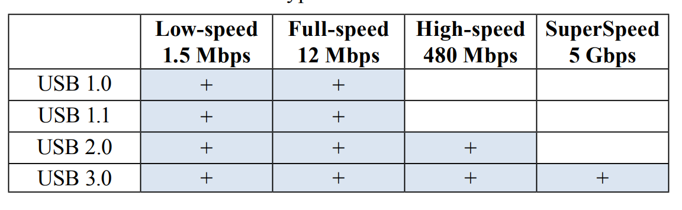

1. **What is the maximum number of USB devices that can be simultaneously connected to the USB interface? What limits this number?**

A USB supports up to 127 devices that can be connected to any USB bus at any given time. **This number is limited by the 7-bit address field.** *Note that address 0 is not used as it has a special purpose, consequently the maximum devices number is equal 27 – 1 = 127*.

1. **List the key features that comprise the USB implementation.**

----------------------------------------------------------------------------------------------------------------

----------------------------------------------------------------------------------------------------------------

----------------------------------------------------------------------------------------------------------------

----------------------------------------------------------------------------------------------------------------

1. **How long of a cable can be used to connect USB devices? What is the maximum distance between the device and the computer that can be achieved using the hubs?**

The maximum cable length is determined by specific electrical properties of the interface. The USB specification limits the length of a cable to 5 meters for full-speed devices and 3 meters for low-speed devices.

Many USB devices can be connected to the same bus with hubs which can have 4, 8, or even 16 ports. According to the specification, the maximum distance of the device from its host is about 30 meters, accomplished by using 5 hubs.

1. **Specify the main electrical parameters of different USB versions: voltage, nominal and maximum unit loads.**

The USB serial interface can also provide power to devices connected to it. **The USB 1.x** and **2.0 specifications** provide a 5V supply on a single wire from which is connected USB devices may power themselves. The specification provides for no more than 5.25V and no less than 4.75V (5V±5%) between the positive and negative bus power lines.

The bus specification defines a unit load as **100mA** in USB 2.0, and **150mA** in a USB 3.0. A maximum of 5 unit loads (500mA) can be drawn from a part in USB 2.0, which was raised to 6(900mA) in USB 3.0.

**Devices that need more than specified unit loads or higher than 5V must provide their own power.**

1. **List USB connectors and specify pin assignments.**

USB has 4 wires. 2 are for (+5V and GND). The remaining two are twisted pair differential data signals (D+ & D-). There are 2 types of connectors. Type A & Type B. There’s also a mini-B connector (smaller portable electronics).

USB connector pin assignments ^^^

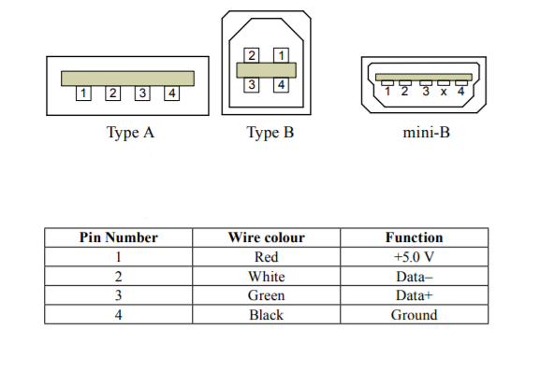

And mini USB pin assignments below.

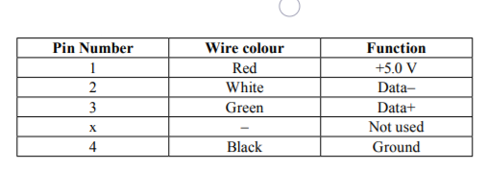

A mini-B USB connector has a fifth pin called ID, thought this pin is not used.

1. **Explain the NRZI data encoding technique used by the USB. Draw the example of bit sequence (0001111111110101) encoded using NRZI.**

NRZI (Non Return to Zero Invert) encoding and differential signaling to transfer information across USB cables. NRZI encoding, a “1” is represented by no change in level and “0” is represented by a change in level. ***I GUESS IT CHANGES*** ***ON A 1 ACCORING TO THE INTERNET?***

1. **Explain the speed identification mechanisms for low speed, full speed, and high speed devices.**

---------------------------------------------------------------------------------------------------------------- ----------------------------------------------------------------------------------------------------------------

----------------------------------------------------------------------------------------------------------------

----------------------------------------------------------------------------------------------------------------

----------------------------------------------------------------------------------------------------------------

1. **Why USB devices are assigned to a particular device class? Give some examples of USB devices classes.**

The individual class specifications describe specific characteristics and attributes. Every device class has different drivers. If a USB does not confirm the one of the standard classes, it must include its own device driver for the operating system. (Bluetooth adapter – wireless controller; Webcam – video device).

1. **Depict and explain the USB packet formats.**

--------------------------------------------------------------------------------------------------------------------------------------------------------------------------------------------------------------------------------

----------------------------------------------------------------------------------------------------------------

----------------------------------------------------------------------------------------------------------------

1. **What transfer types are used by the USB? Explain these transfer types.**

CONTROL TRANSFER – used to transfer specific requests to USB devices and are most commonly used during device configuration.

ISONCHRONOUS TRANSFER – have guaranteed delivery time but no error correcting. Generally used in applications, such as audio or video data steam.

INTERRUPT TRANSFER – used for devices that must receive the host’s or device’s attention periodically. Keyboards and mice use interrupt transfers to send key press & mouse movement.

BULK TRANSFER – bulk transfer is for transferring large blocks of data with error-free delivery.